
The Train Cafe
Project overview of the GitHub branch and deployment evidence
Source reviewed: Labs/Projects/the-train-cafe (main branch)
Project type | Frontend files | Deployment status
Static cafe website + AWS deployment lab | 4 HTML pages, 1 CSS file, 1 JS helper | S3 live; DynamoDB partial; CloudFront/Cognito/Lambda/API blocked

1. Project overview
The Train Cafe is a themed restaurant website built around the idea of a cafe that exists between destinations. The homepage presents the story, menu, guest reviews, location details, and clear links to reservation and online ordering pages.
The branch also doubles as an AWS deployment record. Static hosting on Amazon S3 was completed successfully, DynamoDB tables were created, and the remaining backend steps were blocked by sandbox permissions affecting CloudFront, Cognito, IAM, Lambda, and API Gateway.
2. What is in the branch
File | Type | Purpose | Key behavior
index.html | Page | Homepage | Hero, menu, about, reviews, map, footer, and sign-in modal trigger
booking.html | Page | Reservation form | Collects guest details and posts JSON to /booking via API placeholder
order.html | Page | Pickup order page | Updates a live cart and posts order data to /order
error.html | Page | Custom 404 | Keeps the train theme for missing pages
index.css | Styles | Global UI system | Dark brown and gold palette, typography, cards, buttons, map and review layout
auth.js | Script | Modal helper | Opens/closes auth modal and switches sign-in vs sign-up views

3. Functional observations
- Homepage sections include the navigation bar, full-width hero banner, destination-based menu cards, an about-us story, a testimonial strip, a map/location block, and a detailed footer.
- The booking page captures full name, email, phone number, date, arrival time, guest count, occasion, and special requests before attempting a POST request.
- The order page lets users add quantities for menu items, displays a running summary and total, validates required fields, and then submits a compact item summary string.
- The integration is not finished in code: both forms still point to a placeholder API Gateway base URL, which matches the README explanation of blocked backend deployment.
4. Visual identity
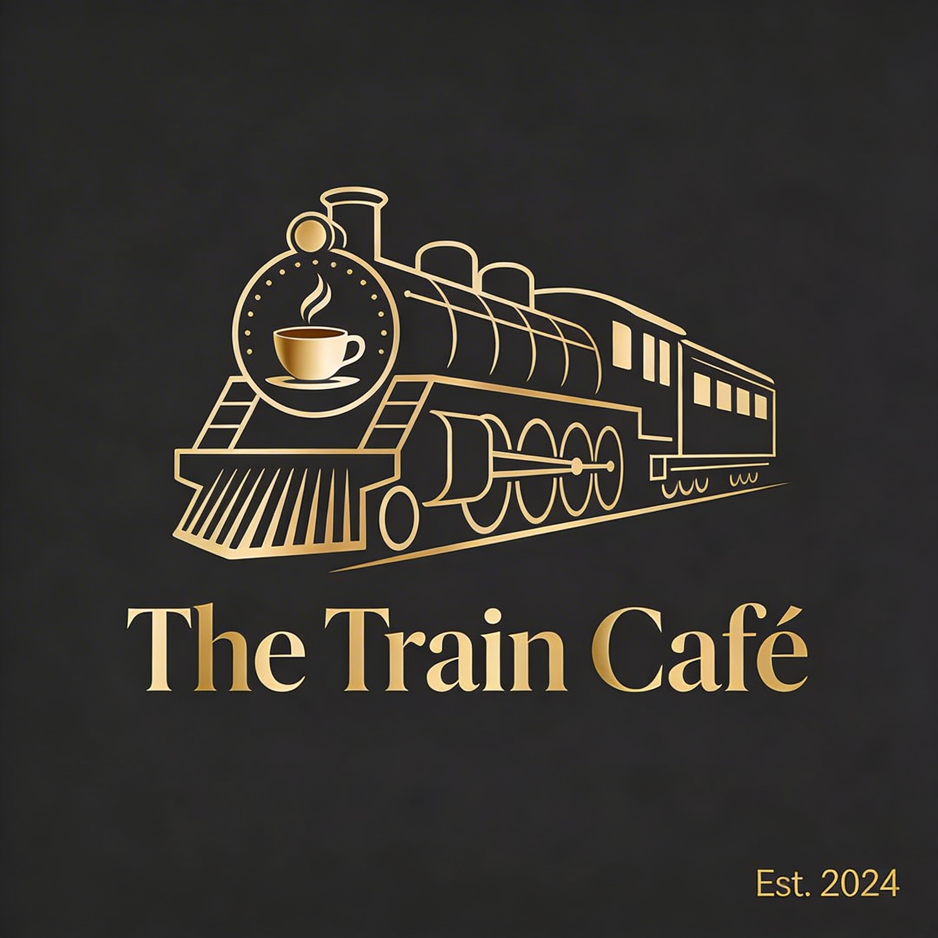 | The design language is cinematic and hospitality-focused: warm amber imagery, dark espresso backgrounds, and muted gold accents. Typography pairs Playfair Display for elegant headings with Lato for navigation and body copy.  This makes the project feel polished and brand-consistent across the homepage, action buttons, menu cards, and supporting pages.

5. AWS deployment status
Service | Status | Notes
Amazon S3 | Completed | Bucket created, public access adjusted, static website hosting enabled, and site confirmed live.
CloudFront | Blocked | Distribution creation hit a wafv2:CreateWebACL authorization error.
Cognito | Blocked | Could not proceed because the S3 website is HTTP and Cognito requires HTTPS callback URLs.
AWS Amplify | Blocked | Fallback HTTPS hosting attempt was denied by amplify:CreateApp permissions.
DynamoDB | Completed | Bookings and Orders tables were created and marked active.
IAM / Lambda / API | Blocked | Role creation was denied, preventing Lambda functions and API Gateway deployment.

6. Selected screenshots
Homepage live on S3
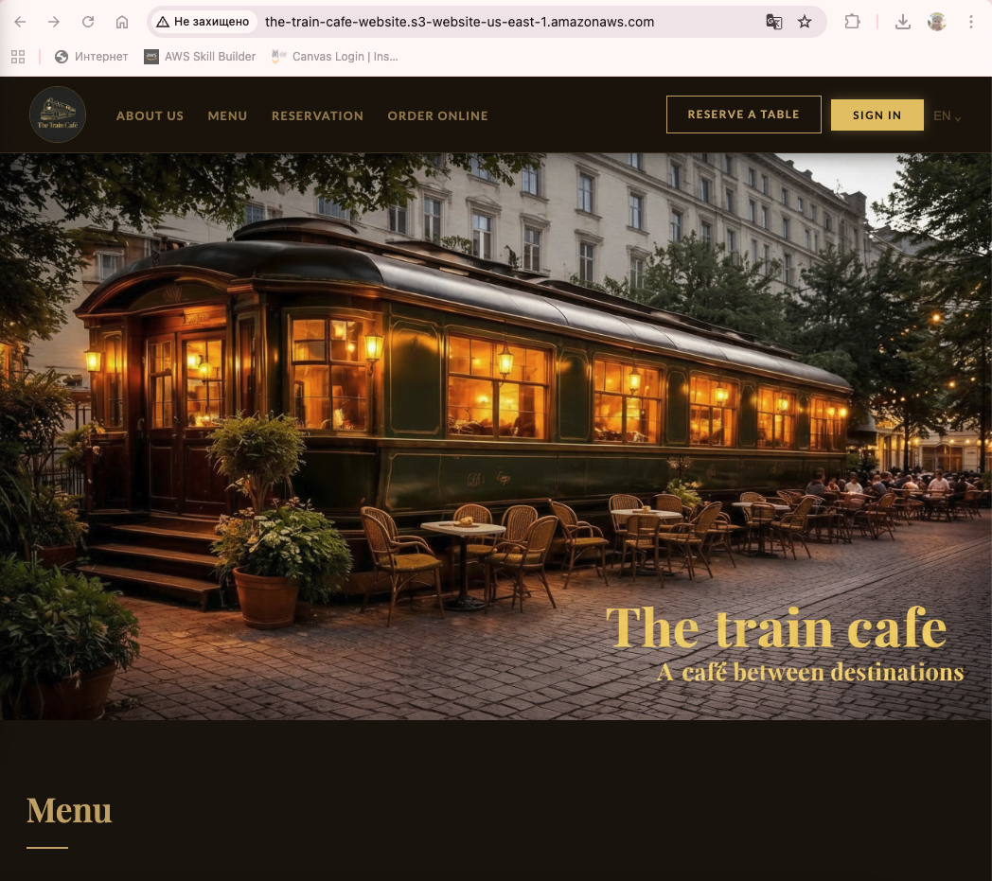
The site is shown working through the public S3 website endpoint.
S3 bucket creation
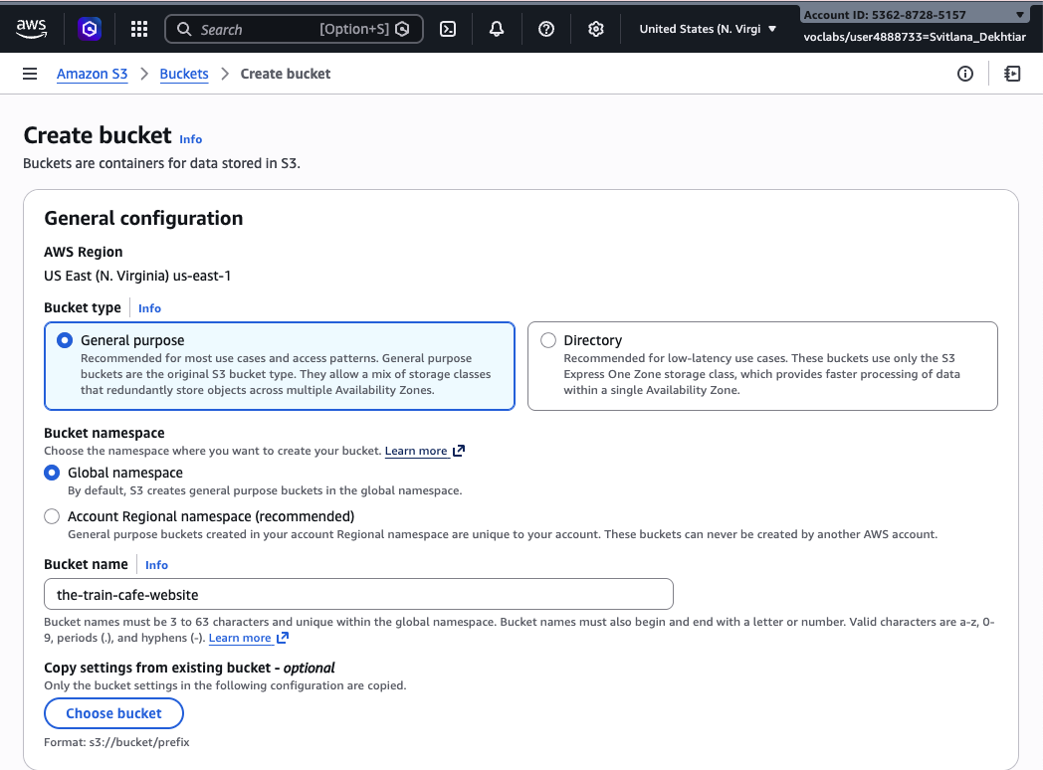
The project bucket was created as the-train-cafe-website in us-east-1.
Static website hosting enabled
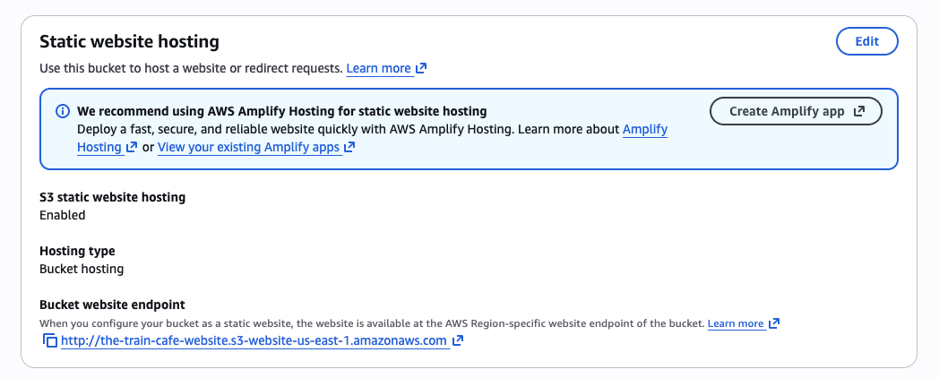
Static hosting was enabled and the S3 website endpoint became available.
CloudFront blocked by WAF permission
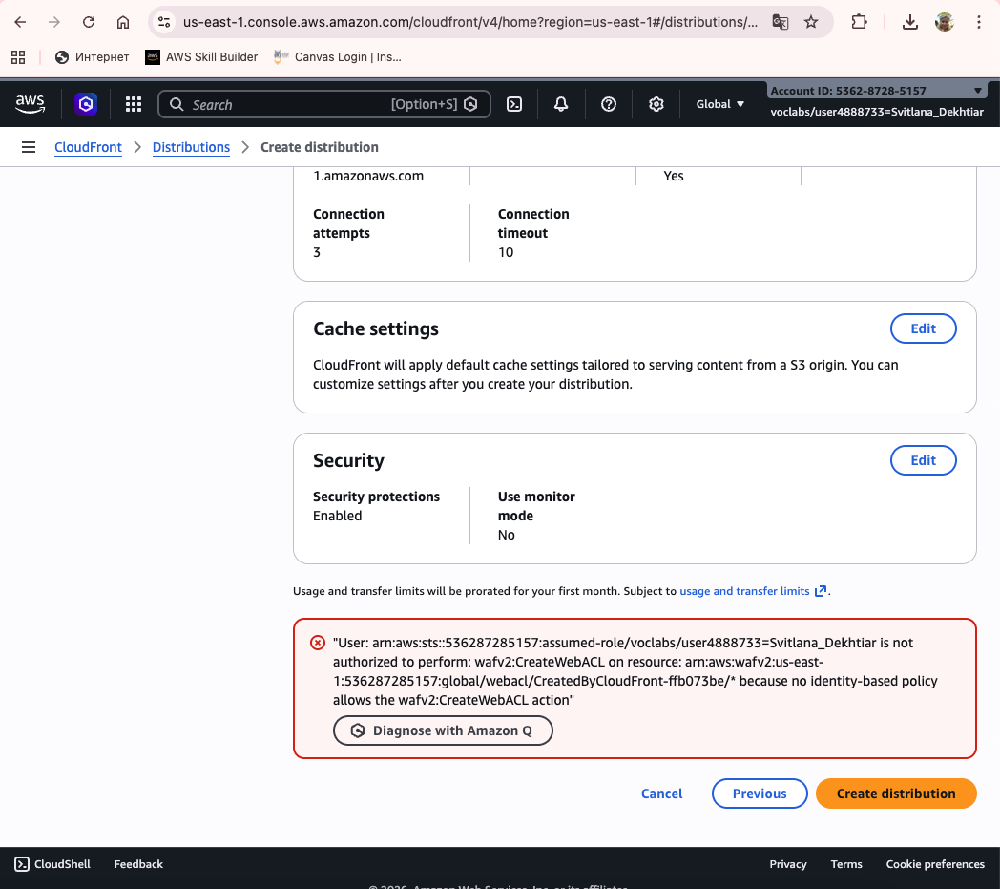
The distribution wizard failed because wafv2:CreateWebACL was not authorized in the sandbox.
DynamoDB bookings table active
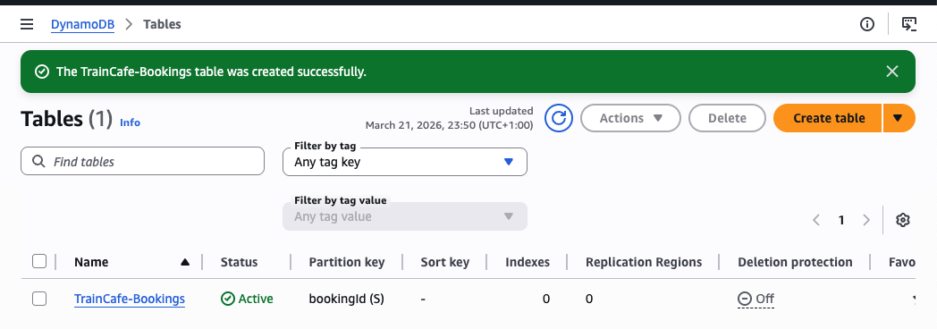
The TrainCafe-Bookings table appears in Active state.
IAM role creation blocked
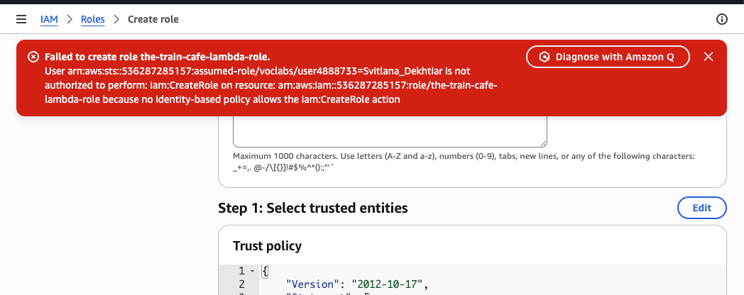
IAM role creation failed, which stopped Lambda and API work.
7. Overall assessment
This branch is well organized for a student project. The concept is memorable, the visual presentation is consistent, and the README documents both progress and blockers clearly.
The frontend is close to deployment-ready for a demo, but the reservation and ordering workflows remain partially stubbed until a real API Gateway endpoint and the blocked AWS services can be provisioned in an environment with broader permissions.

